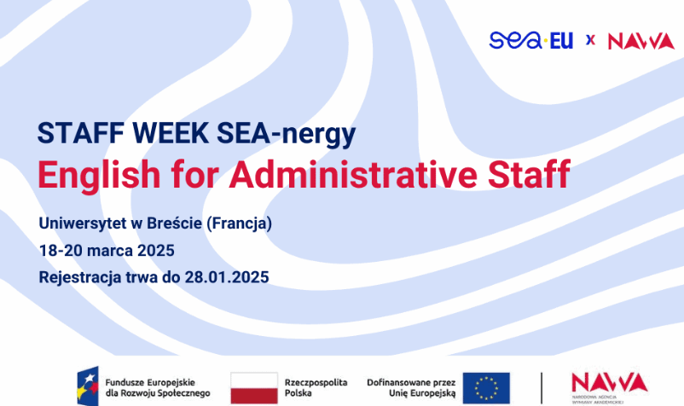

Université de Bretagne Occidentale (France)
March 18-20, 2025
Registration is open until January 28th, 2025

Recruitment Rules for International Mobility under the SEA-nergy Project
BASIC INFORMATION
Name
Staff Week – English for Administrative Staff
Objective
The aim of the course is to develop communication and language skills in English, tailored to the specifics of administrative work at a university. The course program places particular emphasis on the practical application of the language in a professional context, including the handling of international students and staff, correspondence, and participation in meetings and conferences.
Destination and duration of mobility
The international mobility will take place at the SEA-EU partner university, Université de Bretagne Occidentale, from March 18th to March 20th, 2025.

Detailed Program
Link
Set of learning outcomes (competencies):
- Administrative support for English-speaking students and staff
- Conducting formal and informal correspondence in English
- Collaboration with the international academic community
Learning outcomes:
- Knowledge:
The participant:
1.1. knows the vocabulary and terminology related to university administration,
1.2. understands the principles of writing formal and informal correspondence in English,
1.3. is aware of cultural differences and their impact on communication.
- Skills:
The participant:
2.1. creates formal and informal correspondence with international students and staff,
2.2. conducts telephone conversations and video conferences,
2.3. provides information and clarifications regarding administrative procedures
- Social competencies:
The participant:
3.1. is willing to collaborate with individuals from diverse cultural backgrounds,
3.2. understands the importance of clear and precise communication,
3.3. is confident in conducting conversations and communication in English in professional settings

Criteria for assessing learning outcomes
The participant:
Learning outcome | Verification criteria | Verification method
1.1. knows the vocabulary and terminology related to university administration | 1.1.1. names office equipment  1.1.2. knows the types of legal acts of the university | Test
1.2. understands the principles of writing formal and informal correspondence in English | 1.2.1. knows the rules for writing formal correspondence (official letters, emails)  1.2.2. knows the rules for writing informal correspondence (emails to students, friends from foreign universities) | Test
1.3. knows cultural differences and their impact on communication | 1.3.1. understands cultural differences and applies this knowledge in communication with international partners | Test
2.1. creates formal and informal correspondence with international students and staff | 2.1.1. is able to write a formal letter, e.g., an invitation to a conference  2.1.2. is able to write an email to a student, e.g., regarding the rules for submitting a scholarship application | Test
2.2 conducts telephone conversations and video conferences in English | 2.2.1. is able to conduct a telephone conversation  2.2.2. is able to actively participate in a video conference | Test
2.3. provides information and clarifications regarding administrative procedures in English | 2.3.1. is able to explain the rules for submitting scholarship applications  2.3.2. is able to indicate the location for submitting applications | Test
3.1. is ready to engage in collaboration with individuals from different cultural backgrounds | 3.1.1. sends conference invitations to individuals from diverse cultural backgrounds | Test
3.2. is aware of the importance of clear and precise communication | 3.2.1. verifies written statements, including seeking support from others when needed | Test
3.3. is confident in conducting conversations and communication in English in professional situations | 3.3.1. participates in discussions  3.3.2. conducts telephone conversations | Test

REQUIREMENTS FOR MOBILITY
Participants of mobility
To apply for international mobility, an individual must currently be employed as an administrative staff member at the University of Gdańsk at the time of application and the planned mobility. Applicants must not be on any form of leave during the recruitment process or the mobility itself. The declared level of English proficiency for participants is at least B1.
Recruitment
Each individual applying for the recruitment process is required to complete a special registration form: https://forms.office.com/e/YVgPMJQQKR. One of the components of the form is a cover letter justifying the choice of mobility which should contribute to the enhancement of competencies. The form must be completed and submitted by January 28th, 2025.
The order of granting funding depends on the total number of points obtained – applications with a higher total score will have priority when granting funding and will be processed according to the ranking list.
Only individuals who have submitted all required documents and meet the mobility requirements may be qualified for mobility.

Recruitment criteria

1 | Formal criteria | Fulfilled
 | administrative staff status
 | initial English language level minimum B1
 | complete application
 | Substantive criteria | Scoring
2 | Substantive evaluation of the cover letter justifying the choice of the course which should serve to enhance competencies | 0-5
3 | Alignment of the course's subject matter with the participant's professional work | 0-5
4 | Previous participation in a language course within the SEA-nergy project | 0/5

Recruitment results
The committee responsible for verifying and evaluating the applications is required to prepare a ranking list, divided into categories of qualified candidates, reserve candidates, and those who do not meet the criteria. All individuals participating in the recruitment process will be individually notified of the results via email by February 3rd, 2025. The list of selected candidates will also be available on the website: https://sea-eu.ug.edu.pl/aktualnosci/.

RULES FOR PROVIDING SUPPORT
Funding may be granted for mobility taking place between March 18th and March 20th, 2025, plus two additional days for travel. The funding will be provided as a lump sum of 4,500 PLN. The funding must be used to cover travel expenses, accommodation, meals, and the registration fee. A detailed list of the funding rates can be found on the website.
Documentation before mobility
Those who are selected to participate in the course are required to complete:
- an electronic pre-test that will assess the participants' level of knowledge and skills related to the course content before starting the course,
- a delegation request on the employee portal,
- registration on the NAWA platform to confirm the participant's eligibility for the project,
- an electronic registration form from the organizing institution.

Documentation after mobility
Those who complete the mobility are required to:
- complete an electronic post-test that measures the participants' knowledge and skills after the course has been completed,
- submit the original certificate of stay at the partner university.

Completion of mobility

Those who complete the mobility will receive a certificate of participation.
The verification of learning outcomes includes completing a post-test, in which the participant should achieve a higher score compared to the pre-test in order to receive a certificate of enhanced competencies. Both tests are completed remotely via the Microsoft Forms application.

Contact to Coordinator: seaenergy@ug.edu.pl

RECRUITMENT RESULTS
Link to the ranking list
The project "Support for European University Alliances" is implemented by NAWA as part of the European Funds for Social Development program.

