 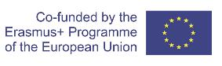

**Guidelines for implementation of the**

***Europass Digitally-signed Credentials***

**in the**

***European University of the Seas (SEA-EU) alliance***

June 2021

Table of Contents

1. Introduction to the Guidelines 3

2. Introduction to the implementation 3

3. Installation and other preconditions 3

4. Process of issuing the digital qualification 4

5. Possibilities for the implementation in the SEA-EU 7

List of references: 8

Annex 1: an example of accessing and sharing your WIRE EDSC 9

# 1. Introduction to the Guidelines

This document has been developed by the Higher Education Digitalisation Expert Group, within the Task 2.4 Digitalisation, under the leadership of the University of Split.

The Higher Education Digitalisation Expert Group consists of:

* Prof. Mile Dželalija, PhD, UNIST, leading,
* Prof. Đurđica Miletić, PhD, UNIST,
* Prof. Maja Ćukušić, PhD, UNIST,
* Ivana Jadrić, UNIST, TWG,
* Mia Majić, UNIST, TWG.

# 2. Introduction to the implementation

For digital issuance of credentials, it is primarily necessary to provide **e-seal** from the appropriate institution. So, the institution is supposed to purchase the e-seal from the registered institution. Institutions that are registered to issue e-seals within specific country are listed on this website: <https://webgate.ec.europa.eu/tl-browser/#/> . All relevant information about the pre-conditions are presented on this website: <https://europa.eu/europass/en/preparing-credentials-europass-digital-credentials#3375> .

It is important that to keep in mind that the verification of acquired credentials that are certified by e-stamp is valid only in e-form. This is especially important when certifying formally acquired qualifications (e.g. diploma or diploma supplement). In addition, it is important to note that the issuance of digital qualifications (when it comes to diplomas) should be in line to the existing legislation at the University.

# 3. Installation and other preconditions

Once the e-stamp has been obtained, it should be installed on a computer on which the person, the "e-stamp keeper" will issue credentials. Furthermore, issuers, who already acquired their institutional e-Seals, will need to have [**NexU**](https://github.com/nowina-solutions/nexu/releases/download/nexu-1.22/nexu-bundle-1.22.zip) installed on their computers. **NexU** is an innovative, open-source multi-browser multi-platform remote signature tool with a purpose to communicate with smartcards. After the whole preparation has been made, the “credential issuer” should visit the following web page: <https://webgate.acceptance.ec.europa.eu/europass/edci-issuer/#/home>, and try to test the e-seal.

It is important to bear in mind that internal rulebook should be created and harmonised according to the e-seal use.

# **4. Process of issuing the digital qualification**

The process begins at the following webpage: [https://webgate.acceptance.ec.europa.eu/europass/edci-issuer/#/home](https://webgate.acceptance.ec.europa.eu/europass/edci-issuer/#/homeg), and following the steps:

1. “Prepare” – testing of connectivity of the system with the e-seal. This is the test that ensure everything is set up properly.
2. ”Build” – the issuer should download the XLS template where all the data should be inserted depending on how detailed information on the certificate need to be included. The fields which are coloured in red are mandatory. It is optional for other details, and issuers should decide in advance how detailed credentials they want to issue.

**This is how a part of the XLS file looks like:**

|  |
| --- |
|  |
| Illustration 1: XLS file. |

1. ”Upload” – prepared XLS file should be uploaded, moving to the next steps of reviewing and digitally sealing credentials. If everything was done properly, there should be a green tick light in the field VALID.

|  |
| --- |
|  |
| Illustration 2: Review message. |

After the file has been uploaded, the ”Review message” will appear. There is an option (under the Actions) to **take a look** (preview) at how this certificate looks like. After that the issuer can decide if additional information should be inserted in the file, etc. Currently, it is possible to upload also a Wildcard as a background picture on credentials, etc. In the future, there should be possible a more sophisticated design.

|  |
| --- |
|  |
| Illustration 3: Sealing the credential. |

After the data has been verified in the system and displayed as successfully processed, it is necessary to mark the Seal option and then the ”Send option”. After selecting the Seal option, an e-stamp is activated that asks for approval with a PIN number, which the "stamp keeper" received together with the USB device with which the e-stamp is activated. After entering the PIN, the Send option sends the credential to the person to whom the credential was assigned by e-mail. Received indicates information that the credential has been successfully delivered to the e-mail of the participant (and Europass wallet)!

The owner of the credential receives an e-mail with the following content:

|  |
| --- |
|  |
| Illustration 4: A message to the owner of the credential. |

In order for an owner to be able to download this qualification and to share it, according to the instructions in the e-mail, the document from the attachment should be downloaded and afterwards uploaded at the following link (according to the email instructions): <https://europa.eu/europass/digital-credentials/viewer>.

The credential that the participant received by e-mail looks like this:

|  |
| --- |
|  |
| Illustration 5: Credential. |

At the left side, there are detailed information about the credential, and on the right side there are information about the authentication and verification of the qualification.

[In the attachment](https://europa.eu/!QP49mm) of the guidelines, there is an example with detailes on the digital credential for the conference participation.

# 5. Possibilities for the implementation in the SEA-EU

The EDC framework can be used for all credentials – from formal education (such as diploma and diploma supplements, formal micro-credentials, etc.), up to credentials related to non-formal and in-formal learning and activities (short non-formal intensive courses, virtual mobility, workshops, educations, conferences).

# List of references:

<https://ec.europa.eu/futurium/en/system/files/ged/europass_background-info_framework-digitally-signed-credentials.pdf>

<https://webgate.acceptance.ec.europa.eu/europass/edci-issuer/#/home>

<https://webgate.ec.europa.eu/tl-browser/#/>

<https://europa.eu/europass/en/preparing-credentials-europass-digital-credentials#3375>

**Practical guidelines:**

<https://www.youtube.com/watch?v=btp7FoqCR00&t=12s>

<https://www.youtube.com/watch?v=gozIqsJJN1A&t=27s>

<https://www.youtube.com/watch?v=mJj9ImAcPuU>

<https://ec.europa.eu/futurium/en/system/files/ged/europass_expert_workshop_fwc_dsc_minutes_v1.0.pdf>

<https://ec.europa.eu/futurium/en/system/files/ged/edci_factsheet_vendors_0.pdf>

# Annex 1: an example of accessing and sharing your WIRE EDSC

**Option 1:**

To view your credential, first you have to save the attachment, then visit <https://europa.eu/europass/digital-credentials/viewer> where you can upload the file to visualise its content.

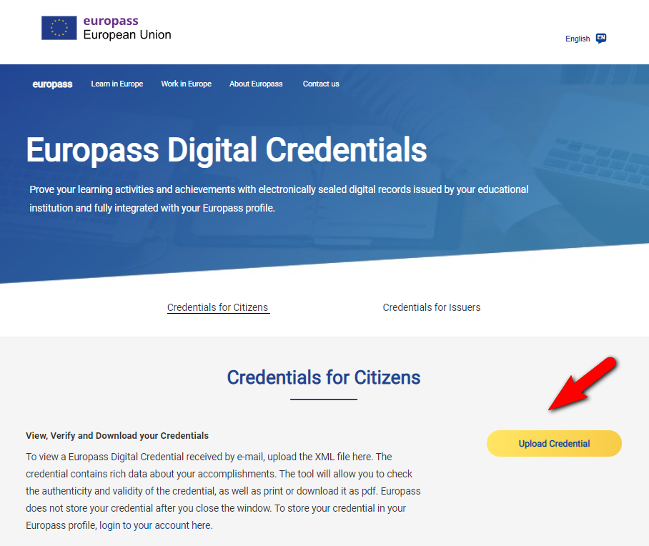

From here you can print the page using your internet browser controls. If you go to Credential details, you can save the image of the credential.

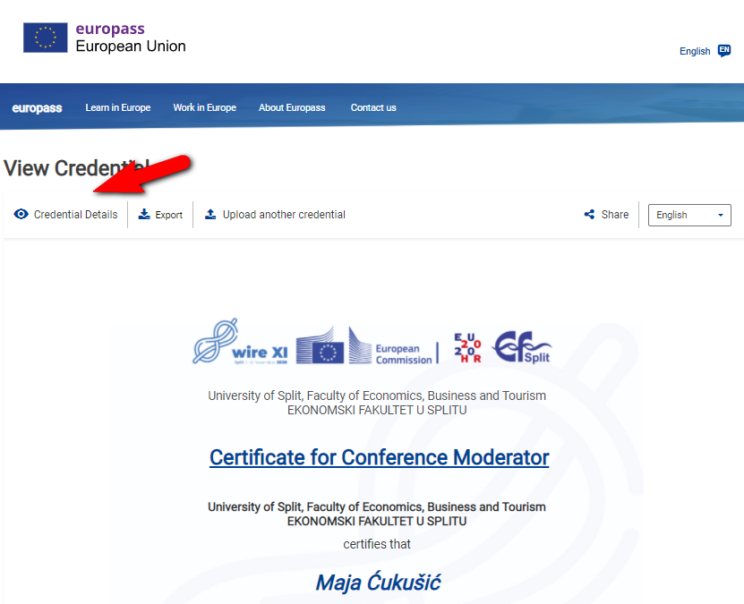

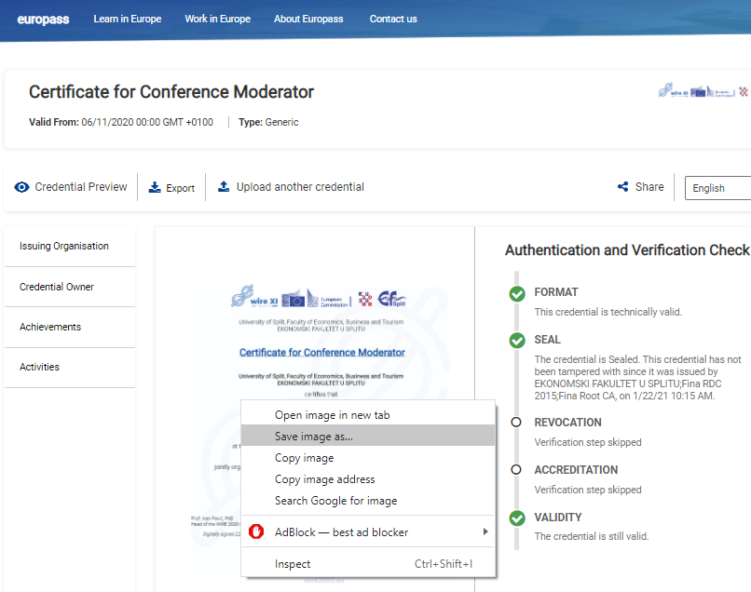

**Option 2:**

Go to europass (<https://europa.eu/europass/en>) and create your account or login. Click on Me (this redirects you to <https://europa.eu/europass/eportfolio/screen/dashboard?lang=en>).

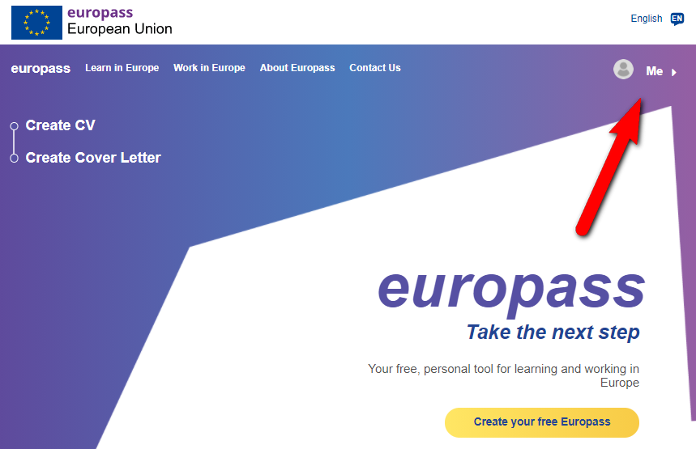

In **My library** you can access your wallet and add any certificate, including this one sent to you in the xml format.

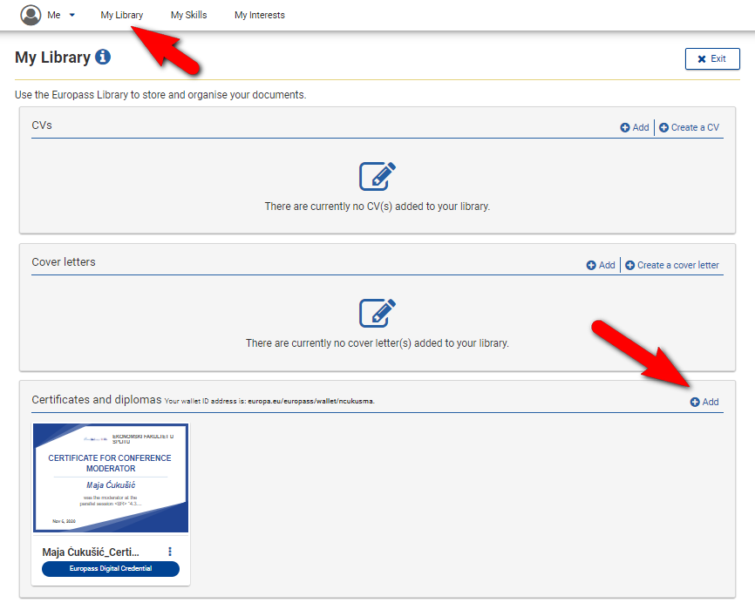

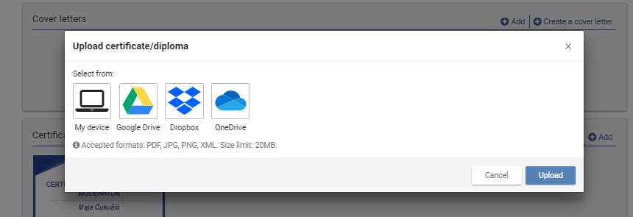

Once uploaded, you can select the option Share, then Generate the link and copy it. The link can then be shared on LinkedIn or with anyone how receives the link (see e.g. <https://europa.eu/!GY89Kc>)

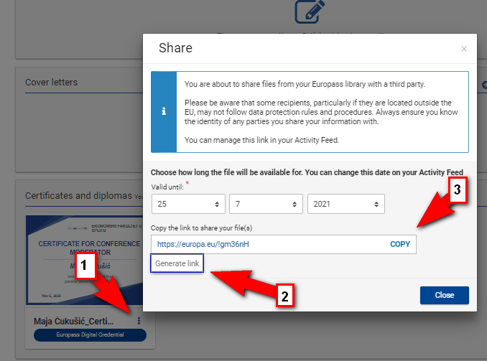

Final qualification:

|  |  |  |  |
| --- | --- | --- | --- |
|  | |  | |
|  |  |  |  |
|  |  |  |  |